MOORING OPERATIONS & PERSONAL SAFETY
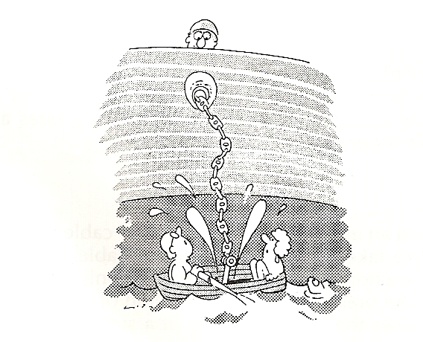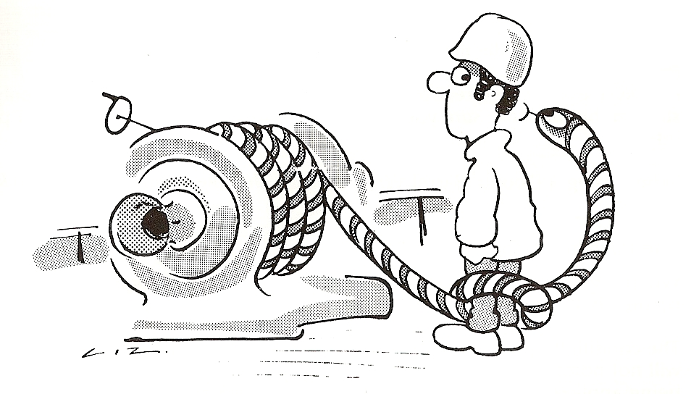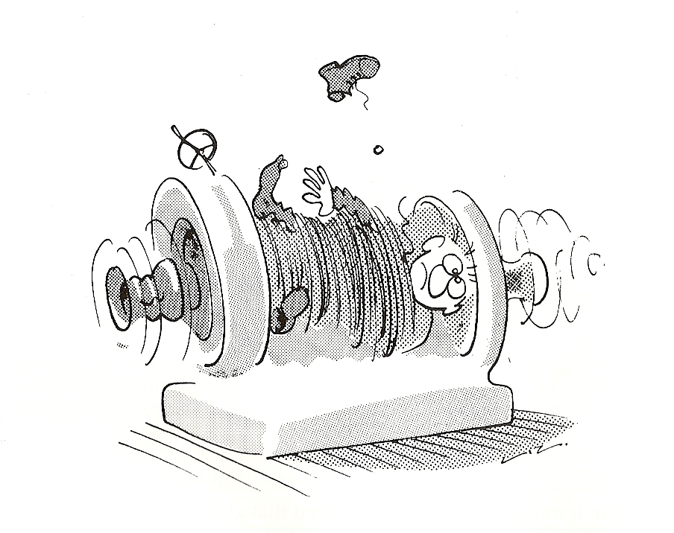

Handling of Moorings:-

- Remember you stand a greater risk of injuring yourself or your shipmate, during mooring and unmooring operations than at any other time.
- Stand Clear of all wires and ropes under heavy loads even when not directly involved in their handling.
- When paying out wires or ropes, watch that both your own and shipmate’s feet are not coil or loop. BEWARE THE BIGHT!!!
- Anticipate and prevent situations arising that may cause a line to run unchecked. If the line does take charge, DO NOT attempt to stop it with your feet or hands as this can result in serious injury.
- When Operating a Winch or Windlass, ensure that the man (or yourself) understands the controls and CAN SEE the officer or person in charge for instructions.
- DO NOT leave winches and windlasses running unattended.
- DO NOT stand on the machinery itself to get a better view.
- DO NOT use a wire direct from a Stowage Reel that has been designed only for stowing, but do make sure you have enough wire off the reel before you put it into use.

- The Windless operator MUST wear:
  - SAFETY GOGGLES: The windlass operator should remember that the wearing of safety goggles may reduce his field of vision, but nevertheless, they must be worn.
  - SAFETY HELMET.
  - SAFETY SHOES.
  - A good pair of OVERALLS with long sleeves.

Flying Fragments can injure the operator. Minor injuries could distract him and set the scene for a more serious accident.

10. SAFETY REMINDERS:
a) DO NOT attempt to handle a wire or rope on a drum end. UNLESS a second person is available to remove or feed the slack rope to you.
b) DO NOT work too close to the drum when handling wires and ropes. The wire or rope could “JUMP” and trap your hand.
c) ALWAYS wear safety helmets with chinstraps properly tightened during mooring operations.

Gear wheels and other moving parts must be protectively covered. If any guards are missing:
- REPORT IT!
- Have them REPLACED as soon as possible.
- Keep your DISTANCE. Master

